

# 

### Semester One Examination, 2018

### Question/Answer booklet

# MATHEMATICS

If required by your examination administrator, please place your student identification label in this box

**SPECIALIST**

**UNIT 1**

## Section One:

## Calculator-free

|  |  |  |  |  |  |  |  |  |  |  |
| --- | --- | --- | --- | --- | --- | --- | --- | --- | --- | --- |
| Student number: In figures |  |  |  |  |  |  |  |  |  |  |

In words

Your name

## Time allowed for this section

Reading time before commencing work: five minutes

Working time: fifty minutes

## Materials required/recommended for this section

***To be provided by the supervisor***

This Question/Answer booklet

Formula sheet

***To be provided by the candidate***

Standard items: pens (blue/black preferred), pencils (including coloured), sharpener,  
correction fluid/tape, eraser, ruler, highlighters

Special items: nil

## Important note to candidates

No other items may be taken into the examination room. It is **your** responsibility to ensure that you do not have any unauthorised material. If you have any unauthorised material with you, hand it to the supervisor **before** reading any further.

## Structure of this paper

|  |  |  |  |  |  |
| --- | --- | --- | --- | --- | --- |
| Section | Number of questions available | Number of questions to be answered | Working  time (minutes) | Marks available | Percentage of examination |
| Section One:  Calculator-free | 8 | 8 | 50 | 53 | 35 |
| Section Two:  Calculator-assumed | 13 | 13 | 100 | 97 | 65 |
|  | | |  | **Total** | 100 |

|  |  |  |
| --- | --- | --- |
| Markers use only | | |
| Question | Maximum | Mark |
| 1 | 5 |  |
| 2 | 5 |  |
| 3 | 8 |  |
| 4 | 6 |  |
| 5 | 7 |  |
| 6 | 6 |  |
| 7 | 9 |  |
| 8 | 7 |  |
| S1 Total | 53 |  |
| S1 Wt (×0.6604) | 35% |  |
| S2 Wt | 65% |  |
| Total | 100% |  |

## Instructions to candidates

1. The rules for the conduct of examinations are detailed in the school handbook. Sitting this examination implies that you agree to abide by these rules.

2. Write your answers in this Question/Answer booklet.

3. You must be careful to confine your response to the specific question asked and to follow any instructions that are specified to a particular question.

4. Supplementary pages for the use of planning/continuing your answer to a question  
have been provided at the end of this Question/Answer booklet. If you use these pages to continue an answer, indicate at the original answer where the answer is continued, i.e. give the page number.

5. Show all your working clearly. Your working should be in sufficient detail to allow your answers to be checked readily and for marks to be awarded for reasoning. Incorrect answers given without supporting reasoning cannot be allocated any marks. For any question or part question worth more than two marks, valid working or justification is required to receive full marks. If you repeat any question, ensure that you cancel the answer you do not wish to have marked.

6. It is recommended that you do not use pencil, except in diagrams.

7. The Formula sheet is not to be handed in with your Question/Answer booklet.

Section One: Calculator-free 35% (53 Marks)

This section has**eight (****8)** questions. Answer **all** questions. Write your answers in the spaces provided.

Working time: 50 minutes.

Question 1 (5 marks)

Relative to the origin $O$, points $A$ and $B$ have position vectors $-3i-2j$ and $i-4j$ respectively.

(a) Determine the unit vector $\hat{c}$, where $c=\vec{AB}$. (3 marks)

(b) Vector $d$ has magnitude $3\sqrt{5}$, is parallel to $c$ and in the opposite direction. Determine $d$.

(2 marks)

Question 2 (5 marks)

Let the displacement vectors $a, b$ and $c$ be $〈11, -4〉$, $〈5, 14〉$ and $〈8, m〉$ respectively, where $m$ is a constant.

(a) Determine the vector $3a+2b$. (2 marks)

(b) Given that $\left|a+b+kc\right|=0$, detemine the values of $k$ and $m$. (3 marks)

Question 3 (8 marks)

Consider the following statement about a simple (no edges that cross) polygon:

*If it has an interior angle sum of 360°, then it is a square.*

(a) Use a counter-example to explain why the statement is false. (2 marks)

(b) Write the converse statement and state whether it is always, sometimes or never true.

(2 marks)

(c) Write the inverse statement and state whether it is always, sometimes or never true.

(2 marks)

(d) Write the contrapositive statement and state whether it is always, sometimes or never true. (2 marks)

Question 4 (6 marks)

(a) Determine the value of the constant $n$, given that the vectors $12i+nj$ and $5i-8j$ are perpendicular. (2 marks)

(b) The vectors $a$ and $b$ are such that $\left|a\right|=18, \left|b\right|=12$ and $a∙b=-33$. Evaluate

(i) $-2a∙3b$. (1 mark)

(ii) $\left(a+b\right)∙(b-a)$. (3 marks)

Question 5 (7 marks)

(a) In the diagram below, the vertices of triangle $ABC$ lie on a circle with centre $O$. Given that $∠ABC=54°$, determine the values of $∠AOC$ and $∠OAC$. (2 marks)

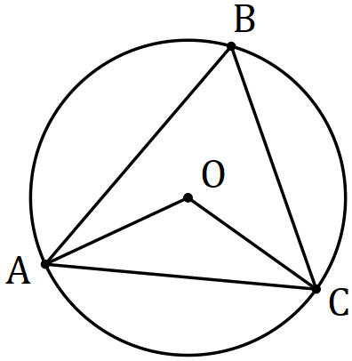

(b) Prove, assuming only basic axioms and properties of triangles, that the size of the angle subtended by an arc at the centre of a circle is twice the size of the angle subtended at any point on the circumference by the same arc. (5 marks)

Question 6 (6 marks)

A drone leaves point $P$ and travels $115$ m on bearing of $340°$ to $Q$, then $30$ m on bearing $070°$ to $R$ and finally $85$ m on bearing $160°$ to $S$.

(a) Sketch a neat diagram to show the path of the drone. (2 marks)

(b) The drone is to return directly from $S$ to $P$. Determine the distance it must fly and on what bearing. (4 marks)

Question 7 (9 marks)

(a) Evaluate $^{16}P_{11}÷ ^{14}P_{11}$. (3 marks)

(b) Express $9!+8!+7!$ in the form $a^{2}b!$, where $a$ and $b$ are positive integers. (3 marks)

(c) Show that for $n∈Z, n≥3$, the sum $n!+\left(n-1\right)!+\left(n-2\right)!$ can always be expressed in the form $a^{2}b!$ where $a$ and $b$ are positive integers. (3 marks)

Question 8 (7 marks)

In the diagram below, two chords of a circle, $BC$ and $DE$, intersect at $F$. $GB$ is perpendicular to $BC$ at $B$ and $GE$ is perpendicular to $DE$ at $E$. The line $GF$ intersects chord $CD$ at $H$.

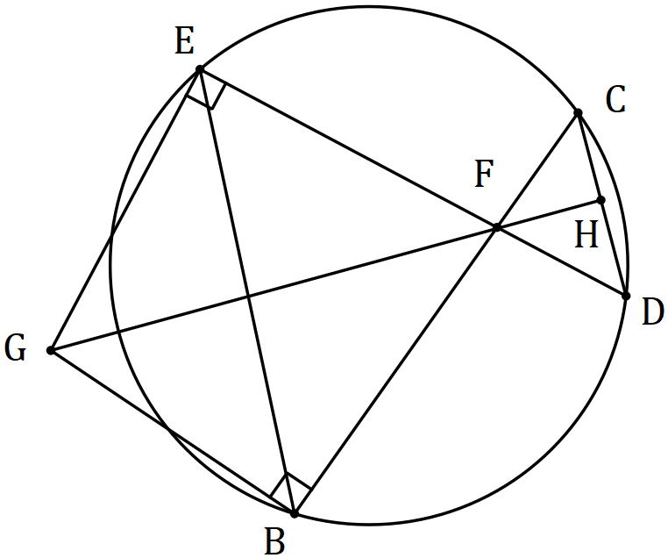

(a) Explain why $GEFB$ is a cyclic quadrilateral. (1 mark)

(b) Prove that $∠CDE=∠EGF$. (3 marks)

(c) Prove that $GH$ is perpendicular to $CD$. (3 marks)

Supplementary page

Question number: _________

© 2018 WA Exam Papers. Baldivis Secondary College has a non-exclusive licence to copy and communicate this document for non-commercial, educational use within the school. No other copying, communication or use is permitted without the express written permission of WA Exam Papers. SN261-111-1.